1) WAP to accept character between a and k and print next four characters

// WAP to accept character between a and k and print next four characters
#include <iostream.h>
#include <conio.h>
main()
{
clrscr();
char i;
cout<<"\n\n Enter a character ";
cin>>i;
if(i>='a'&&i<='k')
{
cout<<++i<<",";
cout<<++i<<",";
cout<<++i<<",";
cout<<++i<<",";
}
else
cout<<" Wrong character inserted. Enter only between a and k";
getch();
}

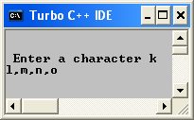

2)WAP to print grades after calculating percentage

//WAP to print grades after calculating percentage
#include<iostream.h>
#include<conio.h>
main()
{
clrscr();
int mat,eng,chem,phy,cs,per;
cout<<"\n\t Enter English marks ";
cin>>eng;
cout<<"\n\t Enter Maths marks ";
cin>>mat;
cout<<"\n\t Enter Physics marks ";
cin>>phy;
cout<<"\n\t Enter Chemistry marks ";
cin>>chem;
cout<<"\n\t Enter Computer Science marks ";
cin>>cs;
per=(mat+eng+chem+phy+cs)/5;
cout<<"You have scored "<<per<<"%"<<endl;
if(per>=90)
cout<<"The grade is S";
else if(per>=80&&per<90)
cout<<"The grade is A";
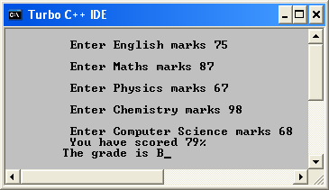
else if(per>=70&&per<80)
cout<<"The grade is B";
else if(per>=60&&per<70)
cout<<"The grade is C";
else if(per>=50&&per<60)
cout<<"The grade is D";
else if(per<50)
cout<<"The grade is F";
getch();
}

3) WAP to print day using switch case construct

//WAP to print day using switch case construct
#include<iostream.h>
#include<conio.h>
main()
{
clrscr();
int a;
cout<<"Enter a ";
cin>>a;
switch(a)
{
case 1:
cout<<"The day is Sunday";
break;
case 2:
cout<<"The day is Monday";
break;
case 3:
cout<<"The day is Tuesday";
break;
case 4:
cout<<"The day is Wednesday";
break;
case 5:
cout<<"The day is Thursday";
break;
case 6:
cout<<"The day is Friday";
break;
case 7:
cout<<"The day is Saturday";
break;
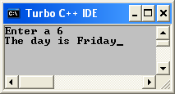
default:
cout<<"Wrong Choice";
}
getch();
}

4) WAP to check negative or positive and print its double or cube on its basis

//WAP to check negative or positive and print its double or cube on its basis
#include <iostream.h>
#include <conio.h>
main()
{
clrscr();
int a;
cout<<"\n\n Enter a number ";
cin>>a;
if(a>0)
{
cout<<"It is a positive number \n ";
cout<<"Its double is "<<a*2;
}
else if(a<0)
{
cout<<"It is a negative number \n ";
cout<<"Its cube is "<<a*a*a;
}
else
cout<<"Invalid Entry";
getch();

}

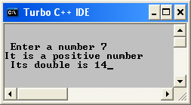

5)WAP to print gross salary after calculating DA,TA and HRA on a given basis

//WAP to print gross salary after calculating DA,TA and HRA on a given basis
#include<iostream.h>
#include<conio.h>
main()
{
clrscr();
float sal, hra, gross;
char city;
float ta,da;
cout<<"\n\n\t Enter basic salary ";
cin>>sal;
cout<<"\n\n\t Enter City ";
cin>>city;
if (sal>=10000)
{
da=(50.0*sal)/100.0;
cout<<"\n\n The Dearness allowance is"<<da;
}
else if (sal>=8000 && sal<10000)
{
da=(40.0*sal)/100.0;
cout<<"\n\n The Dearness allowance is"<<da;
}
else if (sal>=5000 && sal<8000)
{
da=(40.0*sal)/100.0;
cout<<"\n\n The Dearness allowance is"<<da;
}
ta=(10.0*sal)/100.0;
cout<<"\n\n The travel allowance is "<<ta;
if (city=='m')
hra=1000;
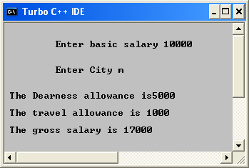
else
hra=500;

gross=sal+da+ta+hra;
cout<<"\n\n The gross salary is "<<gross;
getch();
}

